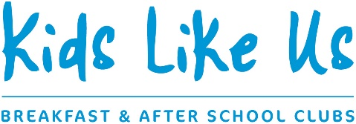

BOOKING FORM
BREAKFAST & AFTER SCHOOL CLUB
**NB: Booking form & registration form required for each child in the family **

Child’s Name: ________________________________________Date of Birth:________________Age_____________Child’s class/year group:________________

Parent’s Name: ___________________________________Tel No__________________________Email:__________________________________

PLEASE COMPLETE THIS SECTION FOR REGULAR DATES
I would like to book a place on the following days every week, beginning on ……………/……………/20……… (please tick appropriate boxes):

 | Monday | Tuesday | Wednesday | Thursday | Friday | Total cost of sessions per week
Breakfast & after school club @ £17.50 per day |  |  |  |  |  | £
Breakfast club only @ £5.00 per session |  |  |  |  |  | £
After school club only  @ £14.50 per session |  |  |  |  |  | £

I have completed a child registration form.
I have paid a one-off registration fee of £30.
I have paid a non-refundable holding deposit – this will be deducted from my first half term’s fees.

Kids Like Us accepts payment via BACS transfer, childcare voucher or cash. Please contact the office for details on 01403 730050 or email info@kidslikeusclubs.co.uk.

Parent signature:__________________________________________Date:_________________

