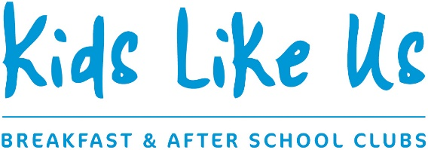

April 2017

COMMITMENT TO SAFEGUARDING AND CHILD PROTECTION
Dear parent/carer
As the registered provider of childcare at Southwater Infant Academy we have a commitment to the safeguarding and protection of all children.
To do this we have a responsibility to consider the wellbeing of all children who attend this setting. This means we are aware of the things we see and hear from children that might indicate the child is at risk of harm. In most situations any matter of concern that is identified will be discussed with you as the parent or carer of this child. We recognise these can be difficult conversations to have but we will raise matters with you as we know the wellbeing and safety of your child is important. In the best interests of your child we hope that we can have an open and honest conversation, should the situation arise.
In certain circumstances we will share these concerns in accordance with the Local Safeguarding Children’s Board Procedures. This means we will contact the Multi-Agency Safeguarding Hub (MASH) in West Sussex. They will make a decision as to whether the concern warrants further assessment or investigation. MASH is the first point of contact with children’s social work services.
In very rare circumstances and where children are seen to be at risk of immediate harm, we may contact MASH without having spoken to you first and gained your agreement.
More detail of the safeguarding and child protection practices for Kids Like Us is contained in our policy. A copy of this policy can be made available to you upon request.
We feel it is important that you are aware of our commitment to safeguarding and child protection, from the beginning of our working partnership and what this may mean in practice.
Yours faithfully

Jenny Evans Graham Richards Louise Richards
Director Director Director

