Welcome to our spring newsletter – it has been a little while since our last newsletter so we have lots to share with you!
Changing Faces
We were delighted to welcome so many new children and their families to club when we opened our doors again. Starting school with its new routines etc, including breakfast and after school club, is such a huge change for the reception children but they have all coped really well and now understand and remember club routines which makes the session more fun for everyone!
Sophie Miles and Helen Boniface-Hook joined the staff team this year and both have settled in brilliantly to their new roles. We love having them both as part of the team and the children enjoy making happy memories with them.
Holiday Club
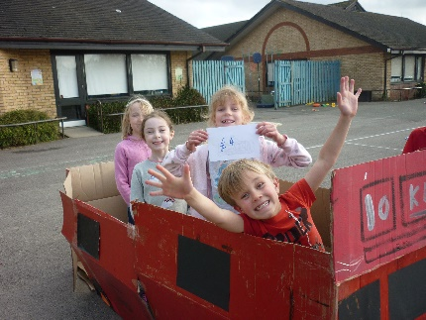
We have thoroughly enjoyed running our holiday clubs at Holbrook Primary School and we are delighted to see some Southwater faces there. In February half term as well as the usual toys and outdoor games we also enjoyed a day full of bird watching and nature, took a “trip” to London on our homemade big red bus, competed in our very own gameshow and even had a day dedicated to the Greatest Showman. Take a look at our Facebook page to see all the fun we had!
The children and parents tell us that the kids are loving the activities and themes, and especially enjoy the freedom to ‘dip in’ and ‘dip out’ of activities as they please. Its lovely to see the new friendships that are being forged between the children from the different schools who are meeting up at holiday club.

Places for our Easter holiday club are going quickly so please book soon to avoid disappointment. Holiday club will also be open during May half term and for two weeks during the summer holiday. To book or for more information call us on 07761 230571 or email us at holidayclub@kidslikeusclubs.co.uk.
Mobile Phones
It is an Ofsted safeguarding requirement that personal mobile phones are not used during club sessions, even if we are outside. Kids Like Us has a business mobile purely for parents to contact us via call or text. Staff personal mobiles are locked in a secure place during every session. As this is a safeguarding requirement it is also extended to parents and carers so please save our staff the embarrassment of having to ask you to put your phone away by not using it at all when you pick your child up. If your child has a mobile phone they will also be asked to lock it into our filing cabinet for safekeeping until they leave the premises. We do all of this to ensure the highest standards of safeguarding for the children in our care.
What did you do today?
We work very hard to provide your children with many different experiences whilst at Kids Like Us. Last time we told you about the various group games and activities that we play each session.
We always have a weekly theme with lots of great craft activities to take part in which the children love. However some children just aren’t into “craft”! So every day we have at least one extra activity. These vary from sensory to science experiments, cooking to group challenges. It is very popular as I am sure you have heard or seen on your arrival or via lovely photos of very happy children on Facebook!
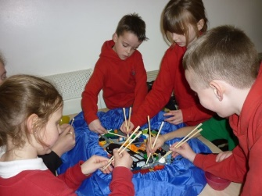
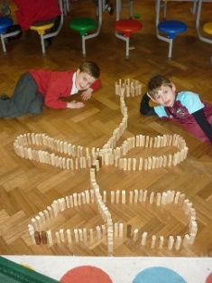
This term the children have really enjoyed the chopsticks challenge , making their own marble runs with paper plate and straws , floating egg experiment, biscuit decorating, baking cheese straws and jelly, cooked rice and lentils sensory. Competitions such as the longest paper chain, highest marshmallow and spaghetti tower, straw towers, malteser races and Lego building have also proved very popular. Alongside our regular favourites of playdough and junk modelling, Loom bands has made a re appearance after the last big craze a few years ago. Your children are kept very busy!!!
We are sometimes asked if we can find time to read with the children. With over forty children most afternoons this is impossible for us to do but we do give the children the opportunity to read every day. When the children arrive in the afternoon and are waiting for all their friends to arrive, books and magazines are put out for them to look at. The children love this and happily look and point out things of interest to their friends. The Infants have books from the Southwater library which are changed regularly so there are always new stories to read and pictures to look at. The juniors have various magazines which we have on subscription so also are constantly changing, including First News Newspaper, National Geographic, Match of the Day and Animals & You and Jacqueline Wilson, which all provide great discussions and debates.
Juniors
The majority of our year 2 children will next year be attending the Junior Academy. You may be wondering what happens with their place at Kids Like Us. Every morning and afternoon up to 20 children from the junior academy continue join us at the Infant Academy. We give them their own space with their own toys and activities suitable for older children; they respond well to the familiarity of Kids Like Us when school routines are changing.
Morning drop off
Please be aware that we are not able to accept your children in the morning until 7:45am due to insurance purposes. Whilst we are thrilled they are eager to get in and start their morning we don’t like having to leave children waiting outside in the cold. Please do not send your children in before this time. Likewise, please ensure all infant aged children (reception – year 2) are dropped off to the club by an adult.
If you would like your child to have breakfast with us, please bring them in no later than 8.20 am so they have a chance to eat it before we have to start tidying away at 8.30. Thank you.
Kids Like Us on Facebook
Don’t forget that Kids Like Us is now active on Facebook! This is a great way for us to provide reminders and share some lovely pictures of your children enjoying themselves. Please ‘like’ our page to receive regular updates and useful information, search for Kids Like Us clubs to find us!
Contact Information
It is an Ofsted requirement that we have up to date contact details; please remember to update us if your contact number, email or address changes. Likewise, we do ask for other emergency contacts in case you are delayed on your journey home and we need to make alternative collection arrangements. Please speak to a member of staff if you are unsure that your contact details are up to date.
September Starters & Sessions
Finally, our books are now open for September bookings. if you have friends or family whose children will be starting at the Southwater Academies in September please mention Kids Like Us to them.
If you need to change the sessions your child attends please email the office with your request and we will do our best to accommodate the changes.
Call us!
Finally, please don’t forget to drop us a text if your son or daughter is not coming into club due to sickness, play dates etc, it saves us time making urgent calls to locate them. The number to contact us for ‘on the day’ messages is 07738 935805. Thank you!
Changes to bookings or invoice queries please email or call the office on the numbers at the top of the newsletter. The office is closed on Friday.
The Kids Like Us Team

