Welcome to our spring newsletter – it has been a little while since our last newsletter so we have lots to share with you!

**Changing Faces**

We were delighted to welcome so many new children and their families to club when we opened our doors again. Starting school with its new routines etc, including breakfast and after school club, is such a huge change for the reception children but they have all coped really well and now understand and remember club routines which makes the session more fun for everyone!

**New Qualification**

The whole team is proud to be able to congratulate Kirsty Cope on her recent completion of her Level 3 in Playwork. Kirsty has worked so hard over the past year and a bit to achieve this juggling a busy home life, running a successful and happy club at Holbrook and completing copious amounts of coursework. Well done Kirsty!

**Holiday Club**

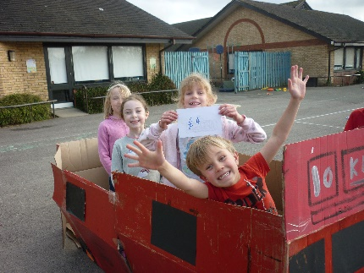We have thoroughly enjoyed running our holiday clubs here at Holbrook and we were delighted to see some familiar faces from our clubs Southwater and Southgate. In February half term as well as the usual toys and outdoor games we also enjoyed a day full of bird watching and nature, took a “trip” to London on our homemade big red bus, competed in our very own gameshow and even had a day dedicated to the Greatest Showman. Take a look at our Facebook page to see all the fun we had! The children and parents tell us that the kids are loving the activities and themes, and especially enjoy

the freedom to ‘dip in’ and ‘dip out’ of activities as they please. Its lovely to see the new friendships that are being forged between the children from the different schools who are meeting up at holiday club.

Places are filling up fast for the Easter holidays so please book soon to avoid disappointment. Holiday club will also be open during May half term and for two weeks during the summer holiday. To book or for more information call us on 07761 230571 or email us at [holidayclub@kidslikeusclubs.co.uk](mailto:holidayclub@kidslikeusclubs.co.uk).

**Mobile Phones**

It is an Ofsted safeguarding requirement that personal mobile phones are not used during club sessions, even if we are outside. Kids Like Us has a business mobile purely for parents to contact us via call or text. Staff personal mobiles are locked in a secure place during every session. As this is a safeguarding requirement it is also extended to parents and carers so **please save our staff the embarrassment of having to ask you to put your phone away by not using it at all when you pick your child up**. If your child has a mobile phone they will also be asked to lock it into our filing cabinet for safekeeping until they leave the premises. We do all of this to ensure the highest standards of safeguarding for the children in our care.

**Encouraging positive behaviour**

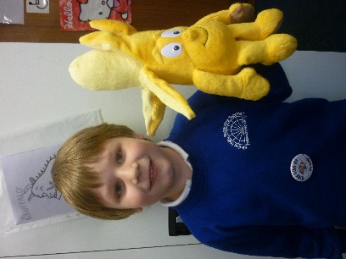At Holbrook we have introduced some new behaviour systems across both rooms. As you are already aware each week we award an infant the role of top banana. This is given out for many reasons such as demonstrating good manners, being a good role model etc. To give the children a little more incentive (not that they need it) we have recently introduced our very own Top Banana teddy. The children will be voting to choose his name so keep an ear out for that news.

In the Junior room we have introduced a new ‘Star’ system. The children gain stars for ‘going on the gold award 5 times’ ‘being a good role model’ or for ‘doing something outstanding’ whilst at the setting. Once the children have gained 5 stars they can trade them in for a 5 star prize such as a hot chocolate with their snack, a small packet of Haribos or a small toy. They can choose not to trade them in and wait until they gain 10 stars and trade them in for a bigger prize!

**What did you do today?**

We work very hard to provide your children with many different experiences whilst at Kids Like Us.

We always have a weekly theme with lots of great craft activities to take part in which the children love. However, some children just aren’t into “craft” so Most days we have at least one extra activity. These vary from sensory to science experiments, cooking to group challenges. It is very popular as I am sure you have heard or seen on your arrival or via lovely photos of very happy children on Facebook!

This term the children have really enjoyed the chopsticks challenge, and biscuit decorating as well as malteser races and Lego building have also proved very popular. Alongside our regular favourites of playdough and junk modelling, Loom bands has made a re-appearance after the last big craze a few years ago. Your children are kept very busy!!!

**Morning drop off**

Please be aware that we are not able to accept your children in the morning until 7:45am due to insurance purposes. Whilst we are thrilled they are eager to get in and start their morning we don’t like having to leave children waiting outside in the cold. Please do not send your children in before this time. Likewise, please ensure all infant aged children (reception – year 2) are dropped off to the club by an adult.

If you would like your child to have breakfast with us, please bring them in no later than 8.20 am so they have a chance to eat it before we have to start tidying away at 8.30. Thank you.

**Courteous parking**

Can we please remind you to be courteous when parking up at the school to drop off or collect your children, making sure you do not block any accesses or driveways.

**Kids Like Us on Facebook**

Don’t forget that Kids Like Us is now active on Facebook! This is a great way for us to provide reminders and share some lovely pictures of your children enjoying themselves. Please ‘like’ our page to receive regular updates and useful information, search for Kids Like Us clubs to find us!

**Contact Information**

It is an Ofsted requirement that we have up to date contact details; please remember to update us if your contact number, email or address changes. Likewise, we do ask for other emergency contacts in case you are delayed on your journey home and we need to make alternative collection arrangements. Please speak to a member of staff if you are unsure that your contact details are up to date.

**September Starters**

We will soon be fielding enquiries for places in September – places are very limited so if you need to change the sessions your child attends please email the office with your request before 5 April and we will do our best to accommodate the changes.

**Call us!**

Finally, please don’t forget to drop us a text if your son or daughter is not coming into club due to sickness, play dates etc, it saves us time making urgent calls to locate them. The number to contact us for ‘on the day’ messages **is 07707 067075**. Thank you!

Changes to bookings or invoice queries please email or call the office on the numbers at the top of the newsletter. The office is closed on Friday.

All feedback is welcome – please feel free to let us know how we are doing.

**The Kids Like Us Team**